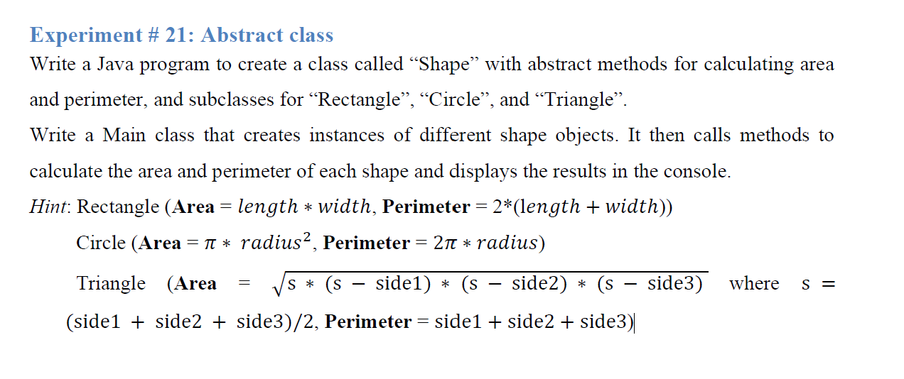

package Lab_8;

abstract class Shape{

    abstract double calculateArea();

    abstract double calculatePerimeter();

}

package Lab_8;

class Rectangle extends Shape {

    private double length;

    private double width;

    public Rectangle (double legth, double width)

    {

        this.length = legth;

        this.width = width;

    }

    @Override

    double calculateArea() {

        return length*width;

    }

    @Override

    double calculatePerimeter() {

        return 2*(length + width);

    }

}

package Lab_8;

class Circle extends Shape {

    private double radius;

    public Circle(double radius){

        this.radius = radius;

    }

    @Override

    double calculateArea(){

        return Math.PI*radius*radius;

    }

    @Override

    double calculatePerimeter(){

        return Math.PI*2*radius;

    }

}

package Lab_8;

class Triangle extends Shape {

    private double side1;

    private double side2;

    private double side3;

    public Triangle (double side1, double side2, double side3){

        this.side1 = side1;

        this.side2 = side2;

        this.side3 = side3;

    }

    @Override

    double calculateArea() {

        double s = (side1 + side2 + side3)/2;

        return Math.sqrt(s*(s-side1)*(s-side2)*(s-side3));

    }

    @Override

    double calculatePerimeter(){

        return side1 + side2 + side3;

    }

}

package Lab_8;

public class Main {

    public static void main(String[] args) {

        Shape rectangle = new Rectangle(5,10);

        Shape circle = new Circle(7);

        Shape triangle = new Triangle(3, 4, 5);

        System.out.println("Rectangle Area:" +rectangle.calculateArea());

        System.out.println("Rectangle Perimeter:" +rectangle.calculatePerimeter());

        System.out.println("Circle Area: " + circle.calculateArea());

        System.out.println("Circle Perimeter: " +circle.calculatePerimeter());

        System.out.println("Triangle Area: " +triangle.calculateArea());

        System.out.println("Triangle Perimeter: " +triangle.calculatePerimeter());

    }

}

package Lab_8;

public abstract class Animal {

    protected int legs;

    protected Animal(int legs){

        this.legs = legs;

    }

    public abstract void eat();

    public void walk(){

        System.out.println("This animal walks with" +legs +"legs.");

    }

}

package Lab_8;

public interface Pet {

    String getName();

    void setName(String name);

    void play();

}

package Lab_8;

public class Spider extends Animal {

    public Spider(){

        super(8);

    }

    @Override

    public void eat(){

        System.out.println("The spider eats indects");

    }

}

}

package Lab_8;

public class Cat extends Animal implements Pet {

    private String name;

    public Cat(String name){

        super(4);

        this.name = name;

    }

    @Override

    public String getName(){

        return name;

    }

    @Override

    public void setName(String name){

        this.name = name;

    }

    @Override

    public void play(){

        System.out.println(name + "is playing with a ball.");

    }

    @Override

    public void eat(){

        System.out.println(name +"is eating cat food.");

    }

}

package Lab_8;

public class Fish extends Animal implements Pet {

    private String name;

    public Fish(){

        super(0);

    }

    @Override

    public String getName(){

        return name;

    }

    public void setName(String name){

        this.name = name;

    }

    @Override

    public void play(){

        System.out.println(name + "is swimming around playfully.");

    }

    @Override

    public void walk(){

        System.out.println("Fish can't walk but swims");

    }

    @Override

    public void eat(){

        System.out.println(name + " is eating fish food.");

    }

}

package Lab_8;

public class TestAnimals {

    public static void main(String[] args) {

        Animal spider = new Spider();

        spider.walk();

        spider.eat();

        Pet cat = new Cat("Whiskers");

        cat.play();

        System.out.println("Cat's Name: " + cat.getName());

        cat.setName("Fluffy");

        System.out.println("Cat's new Name" + cat.getName());

        Pet fish = new Fish();

        fish.setName("Goldy");

        fish.play();

        System.out.println("Fish's name: " +fish.getName());

        ((Fish)fish).walk();

        ((Fish)fish).eat();

    }

}